Week Ending: |  | DAY: |  |  | Subject: Mathematics
Duration: 60mins per lesson |  |  |  |  | Strand: Data
Class: B6 |  | Class Size: |  |  | Sub Strand: Probability & Chance
Content Standard:  B6.4.2.2 Demonstrate an understanding of probability by identifying all possible outcomes of a probability experiment, determining the theoretical and experimental probability of outcomes in a probability experiment |  |  |  | Indicator:  B6.4.2.2.2-3 Predict the probability of a given outcome occurring for a given probability experiment by using theoretical probability |  |  | Lesson:  1 OF 1
Performance Indicator:  Learners can list the possible outcomes of a probability experiment |  |  |  |  |  | Core Competencies:  Problem Solving skills; Critical Thinking;
Teaching/ Learning Resources |  |  | Workbook, compass, grid paper, pencils, rulers
Key words | Collection, organize, predict, presentation, interpretation and analyze, discrete data, continuous data,
References: Mathematics Curriculum Pg. 158
DAYS | PHASE 1: STARTER | PHASE 2: MAIN | PHASE 3: REFLECTION
Monday | Have learners arrange the fractions from the largest to the smallest.  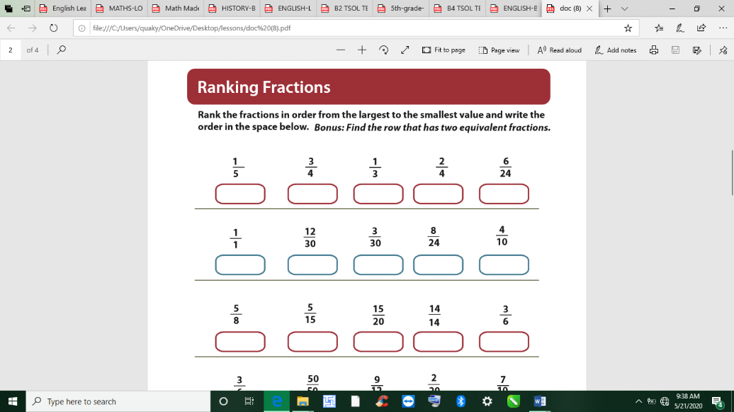  Learners are to complete the work within a given time | Guide learners (in each small group) to carry out the following experiments 100 times, use tallies to record their results, and transfer it to frequency tables:  (i) spinning a 5-sector spinner 100 times;  (ii) spinning an 8-sector spinner 100 times. | Give learners task to complete whiles you go round to guide those who don’t understand.  Give remedial learning to those who may need special help.
Tuesday | Engage learners to play the missing number puzzle.  Use 1 to 4 to finish each equation.  Multiply before you add and subtract  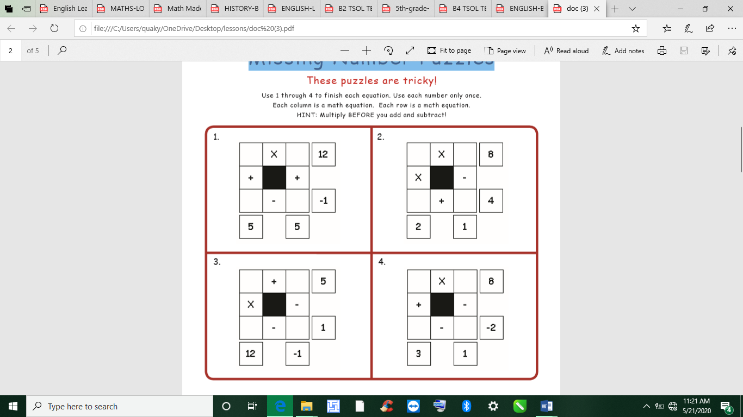 | Ask learners (in each small group) to use the results of the experiments above (recorded in the tables above) to work out the experimental probability and compare to the theoretical probability of the following events with each of the spinners (i.e. table above)  i. pinning a 2  ii. pinning a number greater than 4  iii. pinning a 1 or a 3 | Give learners task to complete whiles you go round to guide those who don’t understand.  Give remedial learning to those who may need special help.
Wednesday | Engage learners to play the missing number puzzle.  Use 1 to 4 to finish each equation.  Multiply before you add and subtract | Put the results from all the small groups for (a) spinning the 5-sector spinner, (b) spinning the 8-sector spinner, together. Ask the class to work out the experimental probabilities and compare to the theoretical probabilities of the events  i. pinning a 2  ii. pinning a number greater than 4  iii. pinning a 1 or a 3 | Give learners task to complete whiles you go round to guide those who don’t understand.  Give remedial learning to those who may need special help.
Thursday | Let learners play games and sing songs to begin the lesson.  Revise with them the previous lesson through questions and answers. | Ask learners their observations as to whether or not the experimental probability is getting closer to the theoretical probability.  Ask them to explain the difference between theoretical probability and experimental probability | Give learners task to complete whiles you go round to guide those who don’t understand.  Give remedial learning to those who may need special help.
Friday | Engage learners in the Mental math game:  Give a sequence of instructions for learners to follow while doing math in their head. | Ask learners their observations as to whether or not the experimental probability is getting closer to the theoretical probability.  Ask them to explain the difference between theoretical probability and experimental probability. | Give learners task to complete whiles you go round to guide those who don’t understand.

